## Task 01: Create Materialized Views - ON DEMAND

CREATE MATERIALIZED VIEW u_dw.monthly

BUILD IMMEDIATE

AS

SELECT customer_country

, brand

, SUM ( price - cost ) AS profit

, COUNT ( * ) AS quantity

FROM u_sa_data.contracts

WHERE TRUNC ( event_dt

, 'Month' ) = TO_DATE ( '7/1/2013'

, 'MM/DD/YYYY' )

AND cost < price

GROUP BY brand, customer_country ;

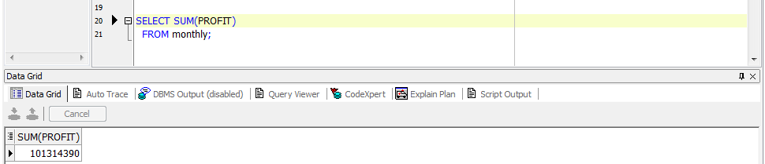



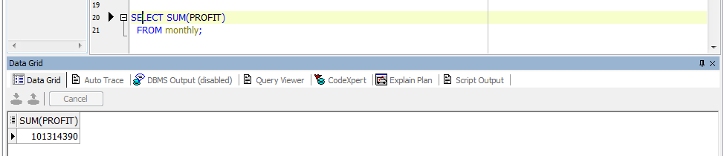

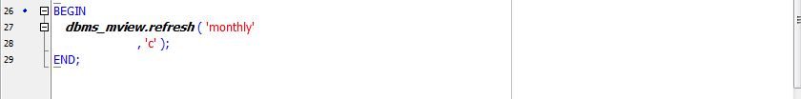

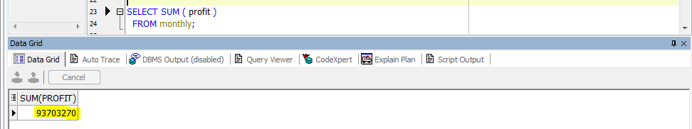

## Task 02: Create Materialized Views - ON COMMIT

CREATE MATERIALIZED VIEW LOG ON u_sa_data.contracts

WITH ROWID, SEQUENCE (event_dt, customer_country, brand, price, cost )

INCLUDING NEW VALUES;

CREATE MATERIALIZED VIEW u_dw.daily

BUILD IMMEDIATE

REFRESH FAST ON COMMIT

AS

SELECT customer_country

, brand

, SUM ( price - cost ) AS profit

, COUNT(*) quantity

FROM u_sa_data.contracts

WHERE TRUNC ( event_dt

, 'day' ) = TO_DATE ( '7/28/2013'

, 'MM/DD/YYYY' )

AND cost < price

GROUP BY customer_country, brand;

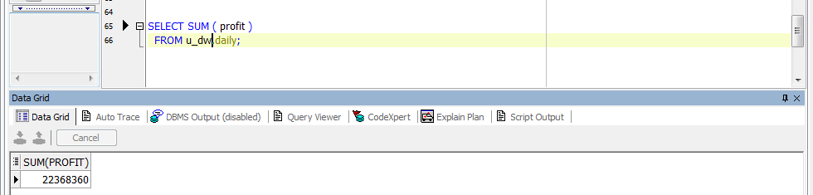

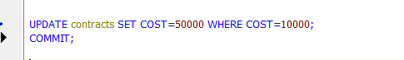

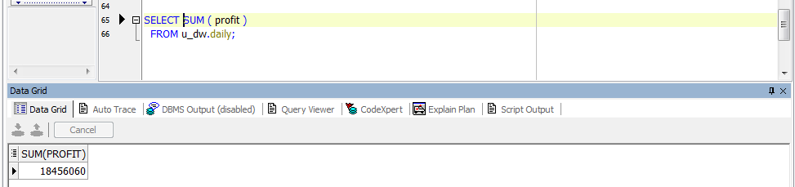

## Task 03: Create Materialized Views - Refreshing at definitive Time moment

CREATE MATERIALIZED VIEW u_dw.monthly_model

REFRESH START WITH SYSDATE NEXT SYSDATE + 1/1440

AS

SELECT customer_country

, brand

, profit

, quantity

FROM u_sa_data.contracts

WHERE TRUNC ( event_dt

, 'Month' ) = TO_DATE ( '7/1/2013'

, 'MM/DD/YYYY' )

AND cost < price

GROUP BY customer_country

, brand

MODEL

DIMENSION BY ( customer_country, brand )

MEASURES ( SUM ( price - cost ) profit, COUNT ( * ) quantity )

RULES

( profit ['TOTAL FOR BRAND', FOR brand IN

(SELECT DISTINCT brand

FROM u_sa_data.contracts

WHERE TRUNC ( event_dt

, 'Month' ) = TO_DATE ( '7/1/2013'

, 'MM/DD/YYYY' )

AND cost < price)] = SUM ( profit )[ANY, CV ( brand )],

quantity ['TOTAL FOR BRAND', FOR brand IN

(SELECT DISTINCT brand

FROM u_sa_data.contracts

WHERE TRUNC ( event_dt

, 'Month' ) = TO_DATE ( '7/1/2013'

, 'MM/DD/YYYY' )

AND cost < price)] = SUM ( quantity )[ANY, CV ( brand )],

profit ['GRANT TOTAL', NULL] = SUM ( profit )['TOTAL FOR BRAND', ANY],

quantity ['GRANT TOTAL', NULL] = SUM ( quantity )['TOTAL FOR BRAND', ANY] )

ORDER BY brand

, profit;

